**Saint Brigid Saint John the Baptist**

25th Sunday in

Ordinary Time

September 23, 2018

**Catholic Church Catholic Church**

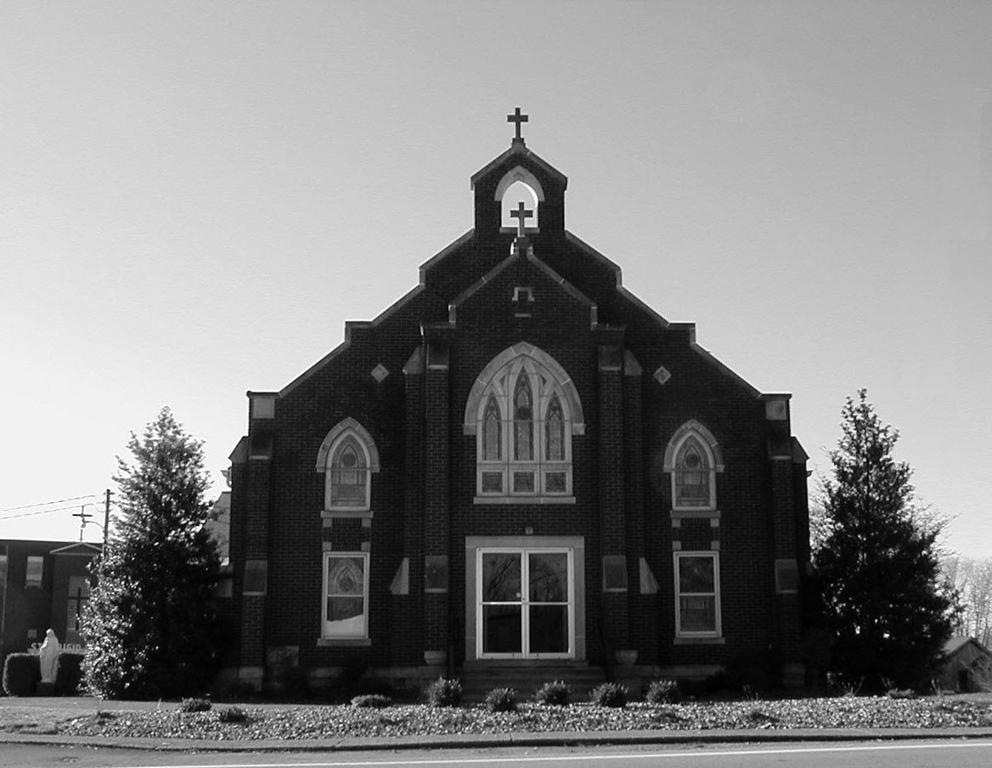

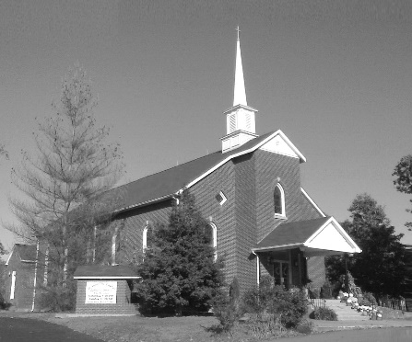

**Pastor:**

***Rev. Daniel L. Lincoln***

Rectory: (270) 877-2546

**Deacon:**

***Michael A. Ryan***

(270) 272-6789

314 E. Main St. 657 St. John Church Rd.

Vine Grove, KY 40175 Elizabethtown, KY 42701

Clustered Parish Office: Clustered Parish Office:

(270) 877-2461 (270) 877-2461

**ANNOINTING OF THE SICK:**

Notify the parish office when a family member is hospitalized.

**BAPTISM:**

Contact the parish office for information about the required preparation class.

**BULLETIN:**

Information must be submitted in writing by note or email to the parish office **no later than 12:00 noon on Wednesdays** for the following weekend. When sending an email, please put “BULLETIN,” and the name of the parish the announcement is for, in the subject line.

**MARRIAGE:**

Contact Father at least 6 months prior to the wedding date to complete required marriage preparations and to schedule the date.

**RCIA (Rite of Christian Initiation of Adults):**

Contact the Worship Chairperson for information.

**DEW MEMORIAL LIBRARY:**

(in St. Brigid Church basement):

Open: Sunday after 9:30 a.m. Mass& 45 minutes before all other Masses.

Email: [brigidvg@bbtel.com](mailto:brigidvg@bbtel.com) **Dir. of Religious Education:**

Website: [www.stbrigidvg.org](http://www.stbrigidvg.org)Lisa Thomas: (270) 735-6930

**Pastoral Associate & Dir. Youth Ministers:**

**of Religious Education:** Angela Churchman:

Deacon Mike Ryan: (270) 877-0546 (270) 268-9963

**Youth Minister:** Ericka Finlay: (502) 612-2644

Lori Law: (270) 723-0157

**MASS SCHEDULE:**

*Saturday (Vigil):*  6:30 p.m.

*Sunday:* 11:30 a.m.

*Wednesday:* 6:30 p.m.

*Friday:* 9:00 a.m.

**RECONCILIATION:**

Saturday before Mass

5:30-6:00p.m. or by appt.

**PARISH COUNCIL MEMBERS:**

*President:* Lauran Thomas

*Secretary:* Theresa Smith

**CHAIRPERSONS:**

*Administration:*  Nick Thomas

*Formation:* Ericka Finlay

*Parish Life:* Bradley Wickersham

*Worship:* Greg Thompson



**MASS SCHEDULE:**

*Sunday:* 9:30 a.m. & 6:30 p.m.

*Monday:* 9:00 a.m.

*Thursday:* 9:00 a.m.

**RECONCILIATION:**

Sunday before Mass

5:30-6:00 p.m. or by appt.

**ROSARY:**

After weekday Masses

**PARISH COUNCIL MEMBERS:**

*President:* Sue Weisshaupt

*Vice-President:* Mike Bramlett

*Secretary:* Judy Cochran

*At-Large Members:* Blake Ryan

& Vincent Thompson

**CHAIRPERSONS:**

*Administration:* Dale Winchester

*Formation:* Tina Yates

*Parish Life:* Tom Billings

*Worship:* Keith Baughman

**Mass Schedule**

**Mass Schedule**

|  |  |  |  |  |  |
| --- | --- | --- | --- | --- | --- |
| **Saturday** | **September 22** | **6:30 p.m.** | **St. John** | **Bruce & Margaret Lincoln** | **Vigil: 25th Sunday in Ordinary Time** |
| **Sunday** | **September 23** | **9:30 a.m.** | **St. Brigid** | **Richard Hughes**  **Bill Brown** | **25th Sunday in Ordinary Time** |
| **“** | **“** | **11:30 a.m.** | **St. John** | **For All Parishioners** | **“** |
| **“** | **“** | **6:30 p.m.** | **St. Brigid** | **Our Parish Family**  **Harold Yates** | **“** |
| **Monday** | **September 24** | **9:00 a.m.** | **St. Brigid** | **Dickie Cecil**  **Helen C. Adams** | **Weekday** |
| **Wednesday** | **September 26** | **6:30 p.m.** | **St. John** | **Fr. Stan Osborne** | **Weekday** |
| **Thursday** | **September 27** | **9:00 a.m.** | **St. Brigid** | **Harold Yates**  **Clarence Jenkins** | **St. Vincent de Paul, Priest** |
| **Friday** | **September 28** | **9:00 a.m.** | **St. John** | **Eric Yates** | **Weekday** |
| **Saturday** | **September 29** | **6:30 p.m.** | **St. John** | **For All Parishioners** | **Vigil: 26th Sunday in Ordinary Time** |
| **Sunday** | **September 30** | **9:30 a.m.** | **St. Brigid** | **Don Rogers**  **Helen C. Adams** | **26th Sunday in Ordinary Time** |
| **“** | **“** | **11:30 a.m.** | **St. John** | **Fr. Stan Osborne** | **“** |
| **“** | “ | **6:30 p.m.** | **St. Brigid** | **Our Parish Family**  **Mae Wooldridge** | **“** |

**INFORMATION FOR BOTH PARISHES**

**VOCATIONS** – Do you know a young man or woman who might make a great priest, brother or sister? Help the Archdiocese of Louisville Vocations Office connect with them! By submitting names through our Called by Name initiative, you'll help us send potential discerners good information and invitations to discernment events. To participate visit: [www.louisvillevocations.com/called-by-name/](http://www.louisvillevocations.com/called-by-name/)

**PYX** – If anyone has a pyx they are no longer using, please turn them in to Father Dan. They are needed for the hospital ministers.

**ABORTION AND ADOPTION –** The number of would-be adoptive parents (of newborn babies) far outstrips the supply in America. Each year in the United States, about 135,000 American children are placed for adoption. Experts estimate somewhere between one and two million couples seek to adopt yearly. Every year, there are about 1.3 million abortions. Sadly, only 4% of women with unwanted pregnancies give their children up for adoption. Every child is wanted and wanted desperately! By Pro-Life Articles Author [www.pro-lifearticles.org](http://www.pro-lifearticles.org)

**PROJECT RACHEL** **–** Healing…Forgiveness…Hope…After the experience of an abortion. If you or someone you know is struggling with the pain from an abortion, please consider Project Rachel – a post abortion ministry. To speak to someone confidentially, call (502) 471-2155 or email [ProjectRachel@archlou.org](mailto:ProjectRachel@archlou.org).

**CONFIDENTIAL PREGNANCY AND ADOPTION COUNSELING** – is available at Catholic Charities for women of all ages experiencing untimely pregnancies. A full range of services are provided, including adoptive placement, legal assistance and counseling for individuals, groups and families. Post-abortion counseling is also available. Services are provided regardless of income or marital status. For more information, call Catholic Charities at (502) 637-9786.

**OPPORTUNITIES FOR LIFE TRAINING** – Opportunities for Life (OFL), a ministry of the Kentucky Catholic Bishops, serving women, men, and families dealing with untimely pregnancies, will be offering a volunteer training workshop at Saint Athanasius Paris, 5915 Outer Loop, Louisville, on **Thursday, September 27, from 10:00 a.m. to 5:00 p.m.** (Lunch will be provided.) OFL volunteers offer hope, compassion, options, counseling, and resources to callers who find the courage to seek help, and volunteers are needed to staff the 24-hour helpline from their homes. Attendees for the training workshop must register in advance. If you have a heart for life affirming ministry, please call (888) 496-3638 to learn more about this ministry and the upcoming training workshop.

**ST. THERESA (RHODELIA) BI-CENTENNITAL – Father George Illikkal and the parishioners of St. Theresa of Avila Church invite you to come celebrate 200 years of faith in Rhodelia, Kentucky on Sunday, October 14, 2018. Archbishop Joseph Kurtz will celebrate Mass at 10:30 a.m. followed by a reception in the Meade-Breck Center/Matt Pike Memorial Gym. Please RSVP by September 22, 2018 with your name and how many will be attending by email:** [**sttheresa@bbtel.com**](mailto:sttheresa@bbtel.com) **or via website: sttheresarhodelia.org or phone: 270-496-4362.**

**WEDDING ANNIVERSARY MASS** – Archbishop Joseph Kurtz warmly invites couples celebrating their 30, 40, 50, 60 & 60 plus years wedding anniversary in 2018 to join others in the Archdiocese for a Mass of Thanksgiving at the Cathedral of the Assumption, 433 S. Fifth Street, Louisville, on **Sunday, October 21, at 2:00 p.m.** Family Members are also invited to the celebration. Each couple will receive a certificate commemorating the occasion. Registration is required. Call the parish office to **register before Friday, October 5.**

* * * * * * * * * * * * * * * * * * *

**St. John and St. Brigid Prayer List**

To add someone to the prayer list, please call the parish office at (270) 877-2461. **Remember to call to remove someone from the list if they are no longer sick, etc.** *Please note that the prayer list has been revised. It is primarily for parishioners and their immediate family members*.

Leslie **Adams-Cerniglia**, Sam **Adams**, April **Allen**, Dennis **Arnold**, Barbara **Ashley**, Donnie Alan **Atcher**, Sue **Banks**, Shannon **Barnes,** Denise **Barnett**, Timothy **Birch**, Teresa **Blaycock**, Charlie **Bowers**, Pauline **Brangers**, Ellen **Bryan**, Richard **Bryson**, Carol **Buchanan**, Linda **Buchanan**, Jeremy & Margie **Buyer**, Deacon Bob **Caspar**, Sue **Caswell**, Ed **Cecil**, J. Mack **Cecil**, Steve **Cecil**, Harlan Ford **Clark**, Judy **Cleaver**, John **Connor**, Betty Jo **Cooper**, Heidi **Correa**, Jeff **Craig**, Glynn **Clutches**, Roan **Dowell**, Karen **Dworshak**, Leroy **Embry**, Marion **French**, Martha **Ford**, Dwayne **Garcia**, Carrie **Gribben**, Mary **Hager**, Mrs. Charles **Hair**, Stephanie **Hall**, Donnie **Hart**, Jimmy **Harper**, Bobby **Harris**, Eileen **Heinen**, Debbie **Hodge**, Betty Lou **Jones**, Charlene **Langley**, Olivia **Leasor**, Jenny **Leonhardt**, Jackie **Long**, Louise **Lucous**, Alma **Mahanna**, Shelly **Martin**, Shirley **Martin**, Martina **Masoni**, Don **Mattingly**, Gerard **Mattingly**, Paul Michael **Mattingly**, Mary **Medley,** Cindy **Miller**, Starla **Miller**, Doug **Osborne**, Duane **Osborne**, Mickey **Padgett**, Frank **Inanely**, Jerry **Phillips**, Annie **Pierce**, Adrianna **Porter**, Jeremy **Porter**, Adrian **Ray**, Allie **Ray**, Mary Agnes **Ray**, Mary Ellen **Ray**, Tonya **Reisinger**, Joel **Rivera**, Lelia Rose **Ryan**, Pat **Ryan**, Caroline **Seabee**, Leon **Skeeters**, Jim **Smith**, Ralph **Staples**, Keith **Tassin**, Anthony **Thomas**, Kenny **Thompson**, Raffaella **Tucker**, Debi **Turner**, Stacey **Vance**, Bill **Waldrop**, Lois **Weaver**, De Neil **Whelan**, Paul A. **Whelan**, Jennifer **Williams**, Sandy **Wiseman**, Zach **Wiseman**, Gail **Wilson**, Don **Wooldridge**, Connor **Wright**, and all the sick, both mentally and physically.

* * * * * * * * * * * * * * * * * * *

**Our Military List**

To add someone to the military list, please call the parish office at (270) 877-2461. **Remember to call to remove someone from the list if they are no longer in the service**.

Lt. Matt **Bednar**, PFC Richard H. **Chapman**, A1C Aaron **Chandler**, A1C Brandon **Davila**, SrA Felicia **Esquivel**, PFC Tyler **Hall**, A1C Ryan **Henley**, A1C Joseph **Manco**, SPC Jacob L. **Nall**, SFC Peter **Novak**, Tony **Rickerl**, James **Rogers**, Tony **Rogers**, Jonathon **Sifford**, Jeffrey **Slade**, Derek **Smith**, CSM Vance **Snider**, Brian **Tomassi**, A1C Daniel **Trombone**, SGT Evan **Vaughan**, PV2 William **Vaughan**, Lisa **Flynn-Veri**, LT Michael **Veri**, LTC Steve **Wickersham**, SGT Clay **Wilson**, TSGT Jeremy **Yates**, Austin **Zulka** and for all who serve and have served our country.

**ST. JOHN THE BAPTIST CATHOLIC CHURCH INFORMATION**

**Monthly Budget Amount Needed:** $ 12,500.00

**Monthly Collection for August:**  $ 12,250.00

**Monthly Collection for September**  $ 7,590.00

**WELCOME PACKETS** – If you would like to become a member, or learn more about St. John Parish, please take a *Welcome Packet* in the church lobby. You may return the census card and the stewardship form to Father Dan or place in the collection basket.

**DISCERNMENT CORE TEAM UPDATE** – We are continuing to work on implementing many of the suggestions that were discussed in the small group gatherings.  Our Facebook page is up and running thanks to Kolbe Disselkamp and Dana Ingram.  Hannah Thomas is working on a web page for the Church.  Our hope is that these two items alone will help to keep everyone more informed about happenings in our parish.  As of August 1, all stewardship lists have been updated and in place.  If you haven't completed a stewardship form they are still available, ask Father or one of the Core Team members.  If you don't see your name appear over the next few months in one of the Mass roles that you wanted to participate in, please reach out to the Core Team and we will make sure that your information is updated.  Over the next several months we will be coordinating meetings for all new committees so that everyone has a chance to participate.  Some committees may only meet once or twice a year, but please try to attend these meetings so that your gifts of time, talent and treasure can be shared with our parish.  Any questions can be directed to one of the Core Team Members:  Clarissa Yates, Rick Newton, Rhonda Newton, Karen Ray, Ericka Finley, Lisa Thomas

**PARISH POT LUCK PICNIC** – Save the date now for our Parish Pic-Nic to be held **Sunday, September 23, following the 11:30 a.m. Mass.** Come for food, fun and fellowship to our annual picnic.

**PARISH COUNCIL** – Will meet on **Monday, September 24, at 6:30 p.m.** at the Parish Hall.

**PIE BAKING CONTEST** - Get ready for the first ever St. John Pie Baking Contest! New this year at the parish picnic, a chance to show off your pie baking skills. Winner to be awarded a ribbon and have bragging rights for a year! See picnic flyer for more details!

**CATECHETICAL SUNDAY –** This weekend we recognize those who have volunteered to teach in our Religious Education Program. We thank them for their gift of time talent and treasure:  Alicia Reneau, Morgan Leasor, Sharon Kennedy, Abby Newton, Jenny Bischoff, Pam Yates, Clarissa Yates, Tracie Price, Vicki Taylor, Angie Geer, Sara Kuhn, Kim Compton, Elaine Geer, Rhonda Newton, Ericka Finlay and Angela Churchman  Please keep this group as well as our students in your prayers for a successful year of religious education as they continue on their journey of faith together.

**RELIGIOUS EDUCATION –** We are off to a good start this year.  There are still a few faces we have not seen and are looking forward to joining us.  Classes are every Sunday from 9:45 to 11:00 a.m. for 3-year-old preschool through high school.  **NO CLASS ON SEPTEMBER 30 DUE TO FALL BREAK. CLASSES WILL RESUME ON OCTOBER 7.** Remember, this is the most important team you can be on. Make RE class an important family priority with good attendance.

**SAFE ENVIRONMENT TRAINING –** We have scheduled a Safe Environment Training workshop for **Monday, November 12 at 6:30 p.m.**  in the Parish Hall.  This training is required for anyone volunteering with our VBS or Religious Education Program.  Training is a one-time requirement and lasts no longer than 1 to 1-1/2 hours.  Any questions please contact Lisa Thomas (270) 735-6930 or [glalt@comcast.net](mailto:glalt@comcast.net)

* * * * * * * * * * * * * * * * * * *

**St. John Liturgical Ministers**

|  |  |
| --- | --- |
| **Vigil: 26th Sunday in Ordinary Time, September 20, 2018** | **6:30 p.m.** |
| Extraordinary Ministers of the Eucharist | Dennis Thomas Becky Thomas Angela Churchman |
| Lector | Rhonda Newton |
| Servers | Audrey Hunt Claire Thomas |
| Greeter(s) | Mary Hall |
| Gift Bearers | Becky French & Family |
| - Ushers | Ben Thomas Kevin Thomas |
| **26th Sunday in Ordinary Time, September 30, 2018** | **11:30 a.m.** |
| Extraordinary Ministers of the Eucharist | Scott Mattingly Martha Thomas Libby Brangers |
| Lector | Scott Mattingly |
| Servers | Mya Reddick Alex Powers |
| Greeter(s) | Trent Thomas |
| Gift Bearers | Nick & Linda Thomas |
| Ushers | Doug Updegraff Fred Williams |
| **Hospital Ministry – Sunday, September 23, 2018** | Joanna Sherrard, Amy Thomas |

**ST. BRIGID CATHOLIC CHURCH INFORMATION**

**Monthly Budget Amount Needed:** $ 25,280.00

**Monthly Collection for August:** $ 26,287.59

**Monthly Collection for September:** $ 20,295.00

**Catholic Higher Education**: $ 721.00

**WELCOME VISITORS** – If you are interested in joining our parish, please pick up a Welcome Packet at the church doors. Complete the registration form and either drop it in the collection basket or mail it to the office. If you just need to update your registration, there are also forms available.

**THANK YOU!** to Gina Ryan and Teresa Morgan, for chairing the Summer Event, to Darlene Staples and Mike Ryan for keeping track of the tickets and required paperwork, to the Osterhage family for taking care of the Cake Wheel, to *Two Taylors Catering* for preparing a wonderful meal, to all the kitchen help and the youth for taking care of bussing tables and taking care of drinks and also for taking care of games, face painting, crafts. Special thanks to Verland Hatmaker and the Gang of 3 guys and a gal for providing wonderful entertainment and great music and also all who purchased Summer Event tickets. We sold all 300 tickets by 3:00 p.m. Thanks also to all who provided silent auction items and purchased silent auction items (we had 49 items, the most ever), and for all who provided desserts for the dinner and for the cakes and pies for the cake wheel. Special thanks for our religious education youth and Lori Law, who helped: Andrew Thompson, Morelia Falcon, Michael Mayes, Jaden Hicks, Breanna Davison, Thomas Webb, Molly New, Caroline New, Tyler Arrigo, Michael Rowe, Kacie Ray, Christopher Morgan, Nathaniel Morgan, Gabe Russell, David Webb, Thomas Webb, Kelsey Adkins and Martine Rogers. Thanks also to helpers Danielle & Blake Ryan and Pat & Sam Wood. Special thanks to Fr. Dan Lincoln for all his support.

**CONGRATULATIONS!** Summer Event Winners were our very own 4th Degree Knights of Columbus Council. They put their name on it and St. Brigid Parish who each won $5,000.00 tax free.  The quilt winner was our very own Alice Moss. The Altar Society and Janice Jenkins sold over 1700 quilt tickets.

**EXTRAORDINARY MINISTERS OF THE EUCHARIST** – October through December 2018 EM schedules may be picked up at the back of the church. Thank you for your continued service.

**ST. VINCENT DE PAUL SOCIETY** – Because of tax law changes all donations to SVDP should be made out to St. Vincent de Paul NOT to St. Brigid Church. Your donation is still tax deductible. THANK YOU for your continued support of SVDP to help the local poor and needy.

**BASKETBALL PROGRAM** – Basketball will not begin until October, so we will post sign-up sheets in August. So far, we have had one adult offer to coach and one adult offer to coach and play in an adult league.

**FROM THE LIBRARY** – **>** There is now an Accelerated Reader section in the library.  Books are labeled by grade level K-8.  Please read and return the book to the correct tub.  Good luck on your testing at school! **>** There is a High School reading section geared toward college bound.  Read and return. **>** Four tables are full of free adult reading.  Read and pass along. **>** The kid table is full of books to be read and returned.  Many new choices. > The large circle table is now a Genealogy resource.  Books need to be checked out and returned. **>** Dr. Dew’s library is still intact.  Read and return where you got them. **>** Thanks to those who have donated books for all to enjoy!

**VOLUNTEER OPPORTUNITY AT FEED AMERICA** – The St. Brigid Youth would like to extend a welcome to our fellow parishioners to volunteer with us at Feed America on **Wednesday, September 26.** The youth group will be volunteering from 4:00-6:00 p.m. but Feed America is open until 7:00 p.m. and you are welcome to stay later. Come for a portion of the time, or whatever works for you. Feed America is located in E-town at 300 Peterson Drive. Families are welcome. Children must be 5 years old and all children 5-15 must be with an adult. If you can’t make it this Wednesday, please mark your calendars for the last Wednesday of every month from 4:00-6:00 p.m. We will be there and would love to have you! If you will be coming send Lori a text @ (270) 723-0157 the day of so I can give Feed America an idea on how many to expect.

**FROM THE ALTAR SOCIETY** – Many thanks for purchasing our quilt tickets.  We will need your help on **Thursday morning, September 27,** after Mass.  There will be no rosary as we will be fall cleaning the church — statues, stations, etc.  Please bring your bucket, rag, small stepladder if you have one.  Cleaner will be provided.  Thanks ahead of time.

**COMMUNION MINISTER UPDATE SESSIONS** – **September 27, 2018, Thursday, 7:00–9:00 p.m. Location: St. Brigid Church.** The sessions are for those ministers needing a mandate renewal, who have already completed the archdiocesan two-session Communion Minister Formation Program. This session will fulfill the requirements for continuing formation for Extraordinary Ministers of Holy Communion. Please add to your calendar. I will put the form applications out three weeks before and make sure a new announcement gets into the bulletin. **There is no fee for EMHC formation, but registration is required. Funded by the Catholic Services Appeal. Please register by one of the following methods:**

* **Internet:** [**https://www.archlou.org/services-directory/archdiocesan-agencies-facilities/worship-office/**](https://www.archlou.org/services-directory/archdiocesan-agencies-facilities/worship-office/)
* **Email:** [**worship@archlou.org**](mailto:worship@archlou.org)
* **Fax: (502) 636-2379**
* **Phone: (502) 636-0296, ext. 1260**
* **Mail:   Office of Worship**

**1200 S. Shelby St.**

**Louisville, KY 40203-2627**

Should you have questions please contact Deacon Mike.

**POWER IN MY HANDS** – October is the month of the rosary. Next week on **Sunday, September 30,** after Mass, the DRE, Knights of Columbus 4th Degree, and Our Lady’s Rosary Makers will be showing the movie, *Power In My Hands*, which was shown in select theaters across America. This revolutionary, feature-length documentary introduces the world to the beauty, timelessness, and power of the rosary through shared of ordinary families and individuals who have experienced miracles as a result of their devotion to this form of prayer. *Power In My Hands* seeks to revitalize America – a society in spiritual crisis and demonstrate the power of praying the rosary. This film will speak to your heart and will be a useful for teachers and catechists, yet it is engaging enough for a family movie night.

**YOUNG AT HEART** – will meet **Wednesday, October 3**, for a pot luck dinner. Games will start at 11:00 a.m. The pot luck dinner will start at 12:00 noon. The parish provides the chicken. Please bring a friend.

**BLOOD DRIVE** – The next blood drive will be held on **Friday, October 12, from 10:00 a.m. to 2:00 p.m.** in the CCC.

* * * * * * * * * * * * * * * * * * *

**St. Brigid Youth Ministry**

**Wednesday, September 26** – Feed America from 4:00-6:00 p.m. is not just for our high school youth but the entire parish. You can come for part or our entire time slot. The minimum age is 5 and all those younger than 16 must be accompanied by an adult. I’ll see you on Wednesday, September 26, at 300 Peterson Dr. in E-town.

If you have any questions, please contact Lori at (270) 723-0157 or email at [stbrigidyouth@hotmail.com](mailto:stbrigidyouth@hotmail.com).

**St. Brigid Monthly Meet and Greet**

St. Brigid Parish hosts a “Meet and Greet” downstairs the 2nd Sunday of each month immediately following the 9:30 a.m. Mass with coffee and donuts. This is a great opportunity for existing parishioners to extend a warm welcome to visitors and anyone interested in joining St. Brigid Parish. Be sure to also visit the Dew Memorial Library.

**The next Meet and Greet will be Sunday, October 14, 2018.**

**St. Brigid Liturgical Ministers**

|  |  |
| --- | --- |
| **26h Sunday in Ordinary Time, September 30, 2018** | **9:30 a.m.** |
| Extraordinary Ministers of the Eucharist P. | Rose Cooper Tina Yates |
| C. | Janey Jenkins Jim Klimesh Patty Sims Nancy Kotarski |
| Lector | John Jenkins |
| Servers | Emily Chandler Alexander Lozano |
| Greeters | Terrie Morgan David & Paula Stoddard |
| **26th Sunday in Ordinary Time, September 30, 2018** | **6:30 p.m.** |
| Extraordinary Ministers of the Eucharist P. | Ron Masoni |
| C. | Richard & Donna Osterhage |
| Lector | Robert Mahanna |
| Servers | Jackie Veri |
| Greeters | Volunteers |
| **Hospital Ministry – Sunday, October 14, 2018** | Ralph and Sherleen Barren |



**FAITH FORMATION NEWS**

**THE CANDY BANK IS OPEN!**

* Make your deposits NOW of individually wrapped Halloween candy at the front of the church.
* Help us cover the cost of the hundreds of trick or treaters at this year’s Trunk or Treat!!

Questions? Call Selina Chandler at (270) 765-3672.

***Marriage Moments –***

When your hobbies differ and compete, does your spouse get stuck with the burden of extra chores, childcare, or unwanted alone time as a result of your recreation? Does your hobby take a lot more time than your spouse’s? If not, rejoice.

***Parenting Pointers –***

“Did you wash your hands before coming to dinner? is a common parental question. But just as important is coming to dinner with a clean heart. Sure, squabbling will happen, but if you as a parent can stay calm and centered, the odds are you can more effectively deflect sibling squabbles or food complaints.

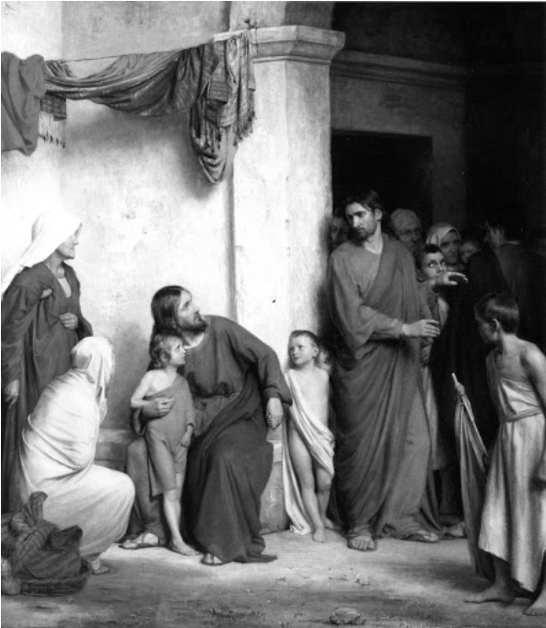

“Whoever receives one child such as this in my name, receives me…”